1. Install nginx and run nginx on port number 81  
   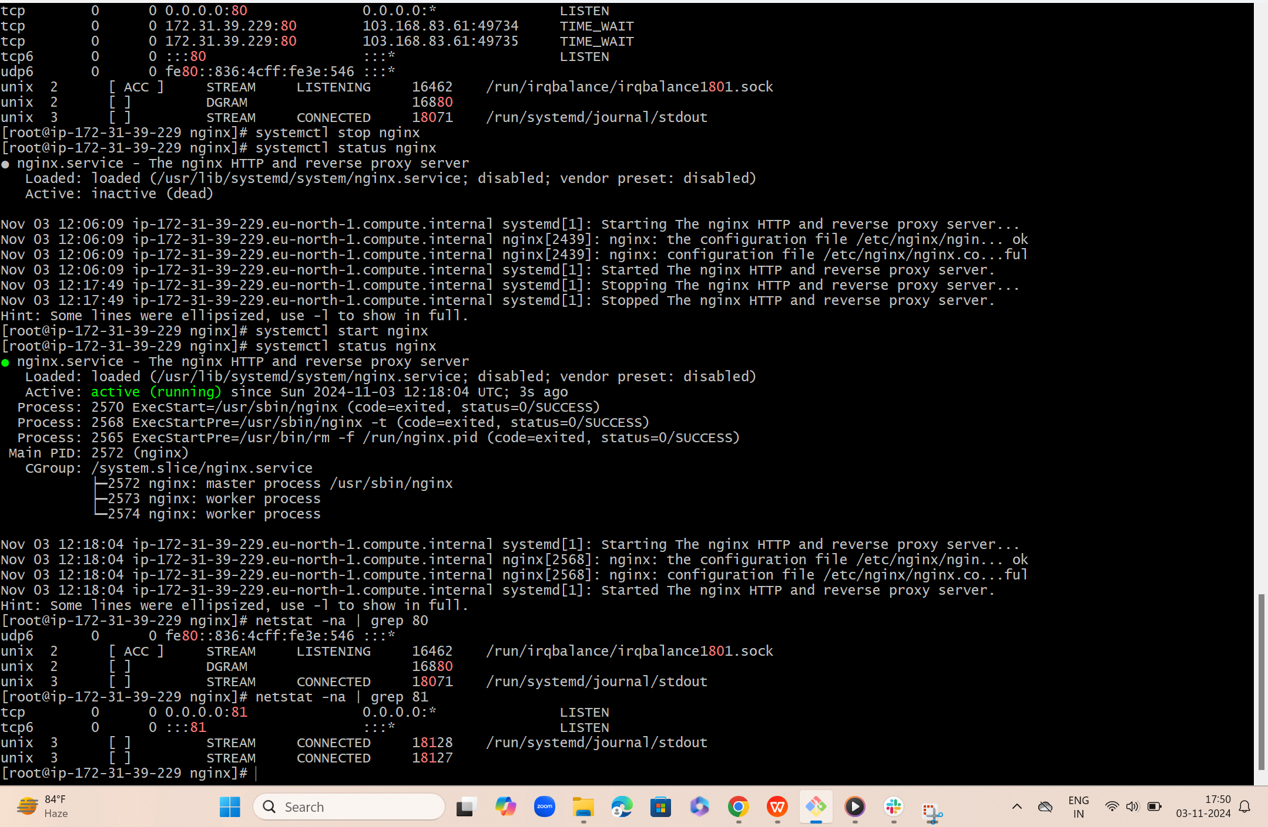  
     
   Port number 81  
   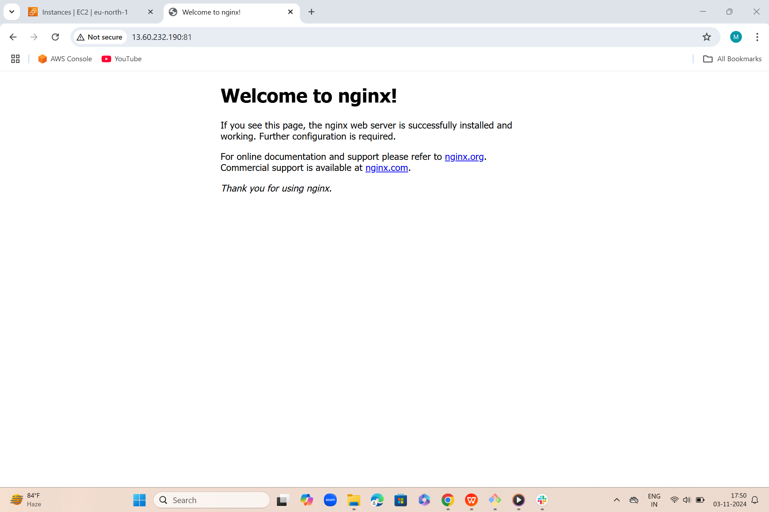
2. Deploy a sample index.html file on nginx  
   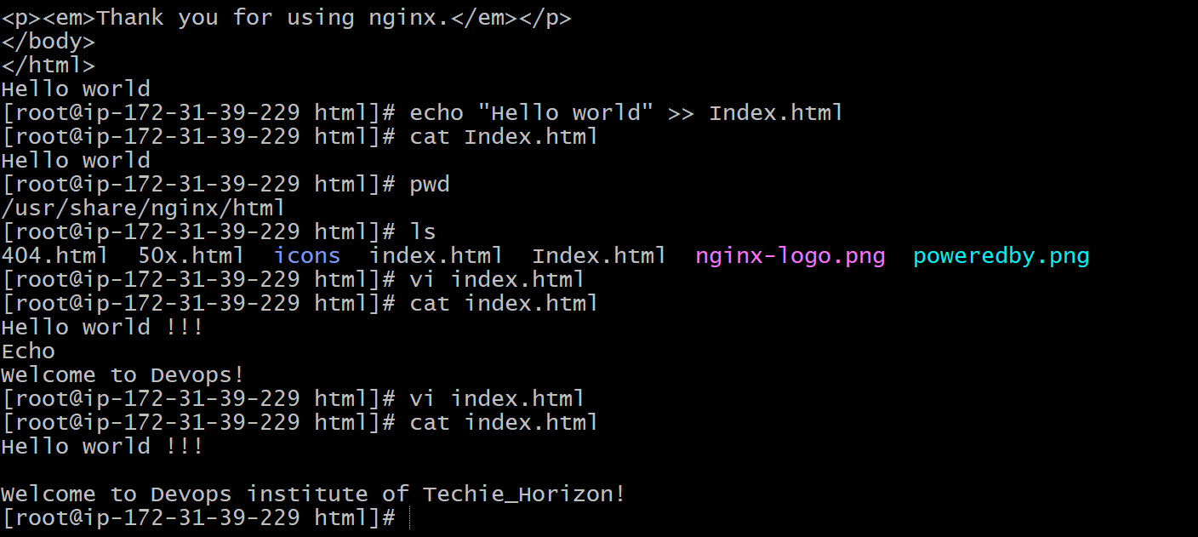  
     
     
   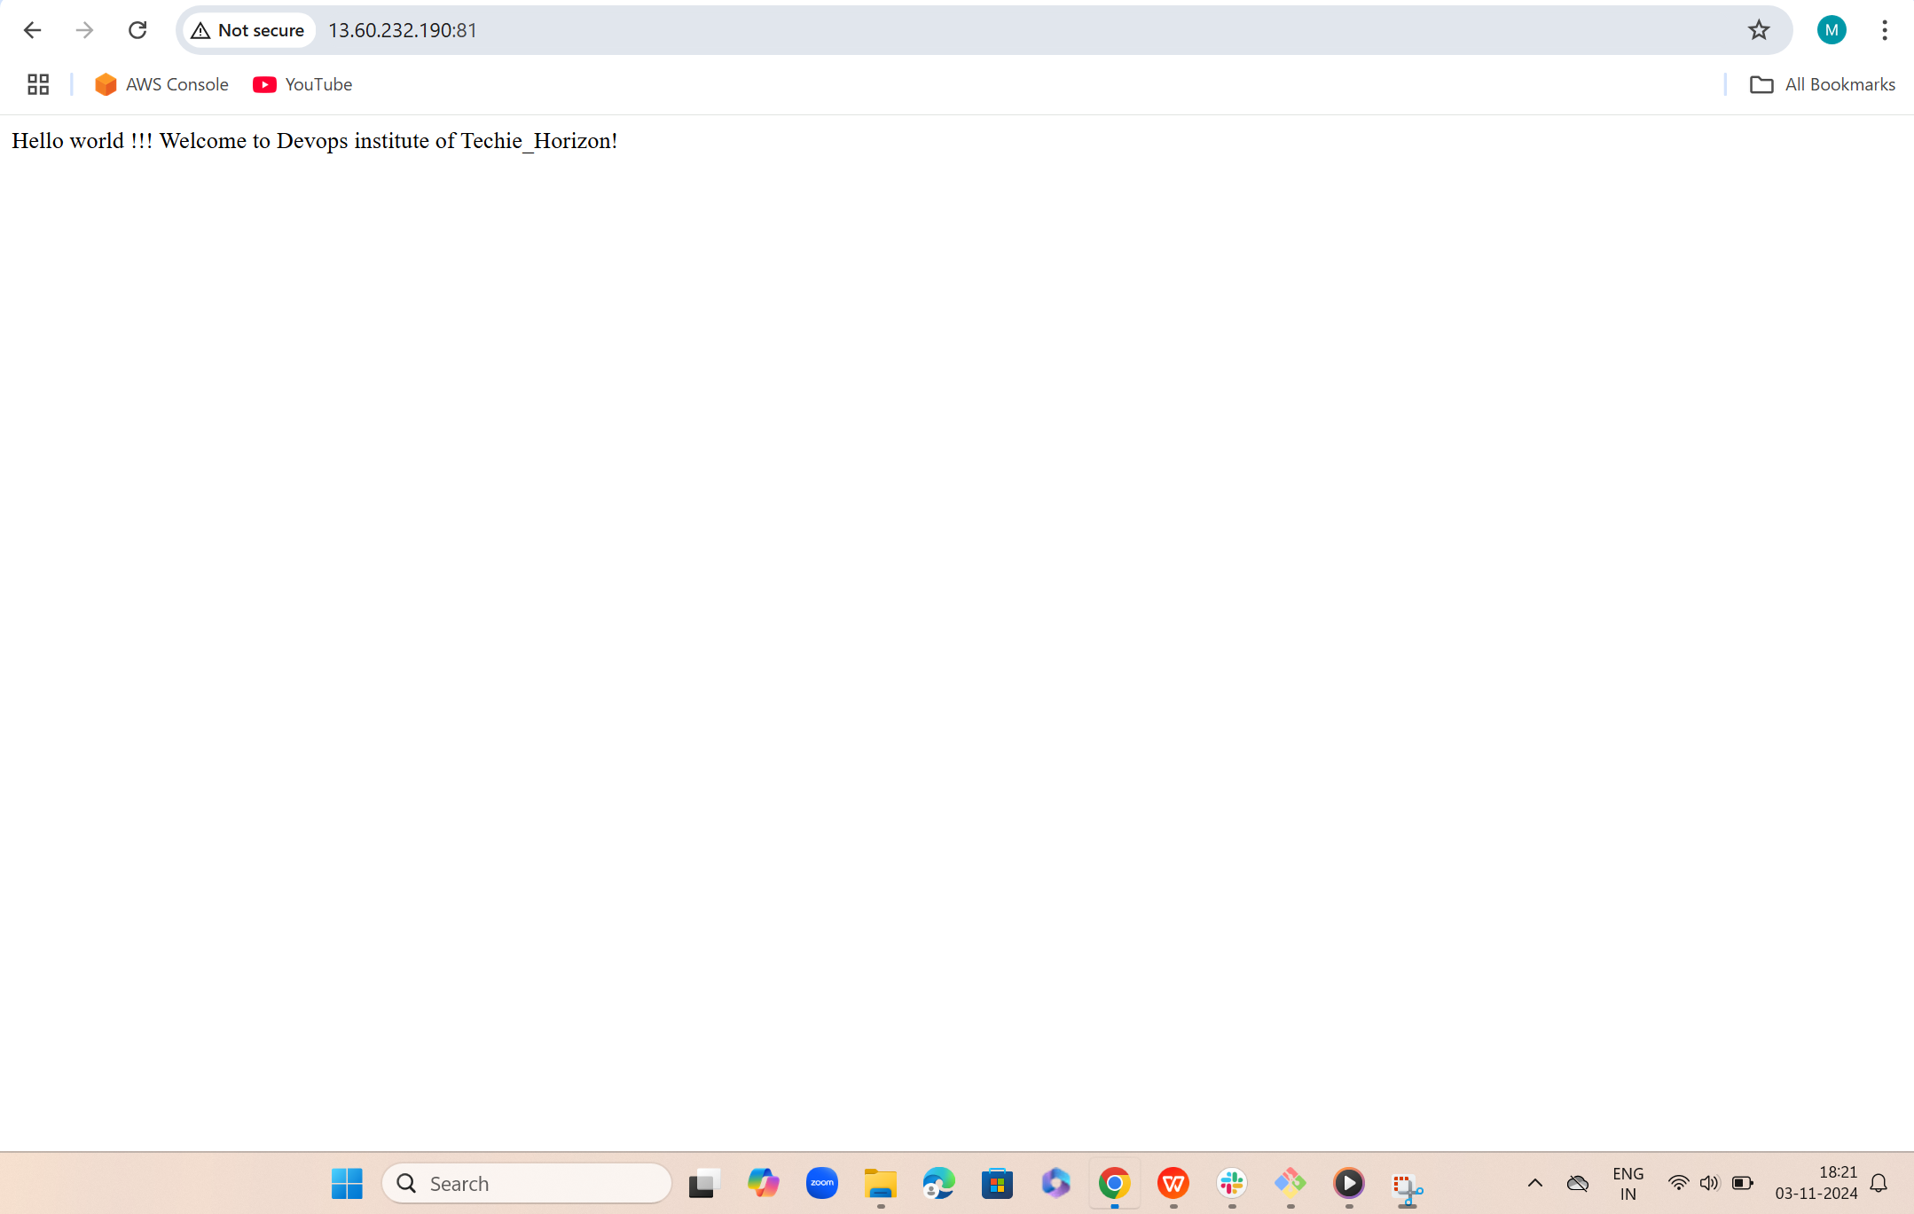

3) Install Apache and run Apache on port number 82  
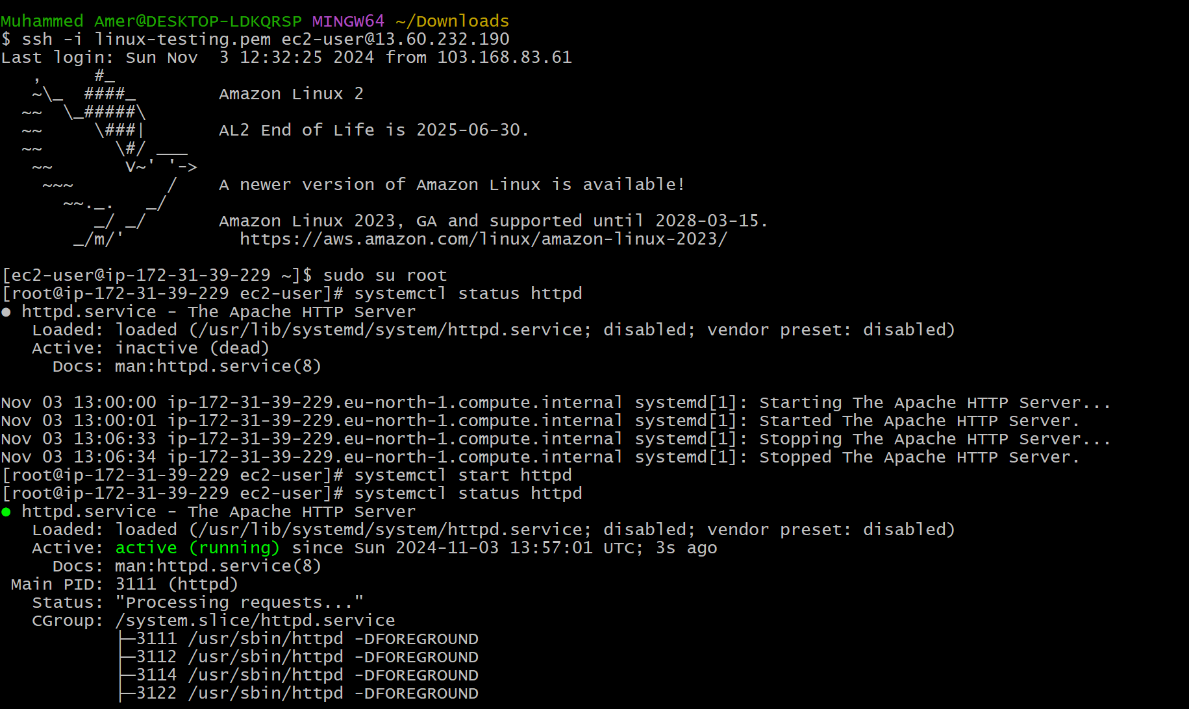

Port number 82  
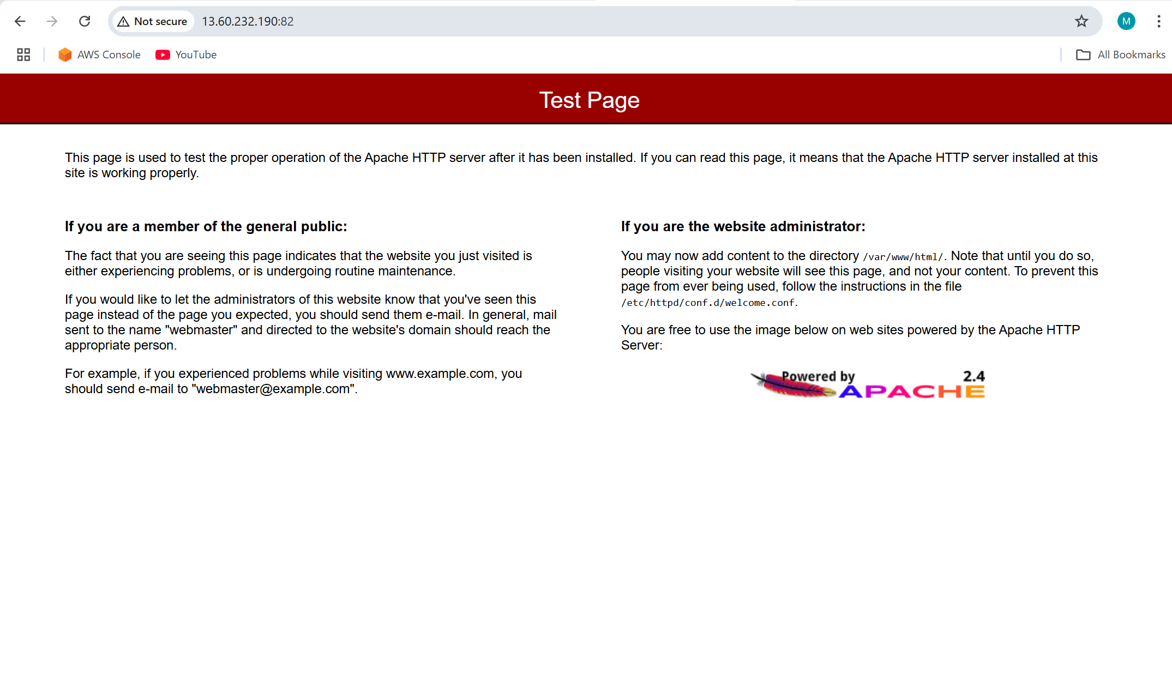

1. Deploy a sample index.html file on Apache  
   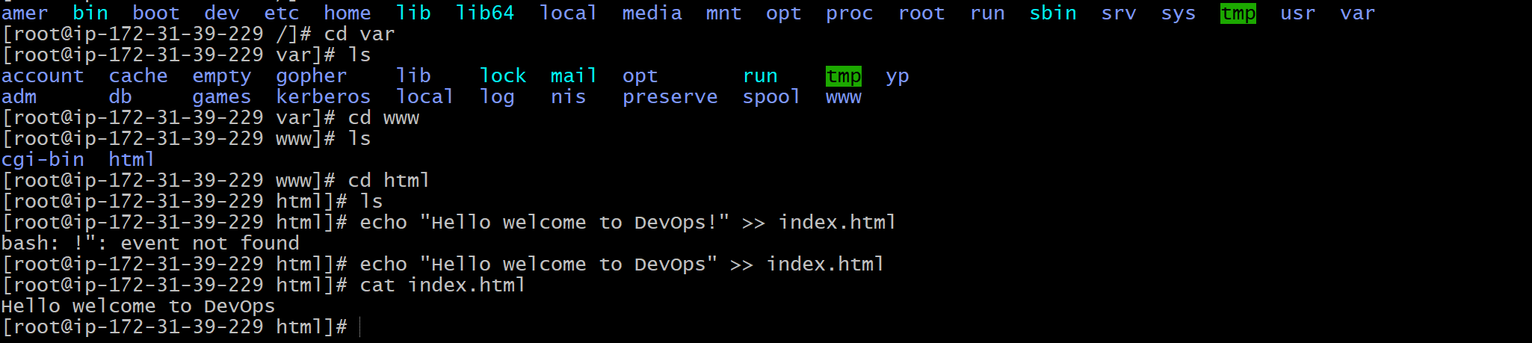  
     
     
     
     
     
   
2. Install Apache tomcat on port number 8082  
   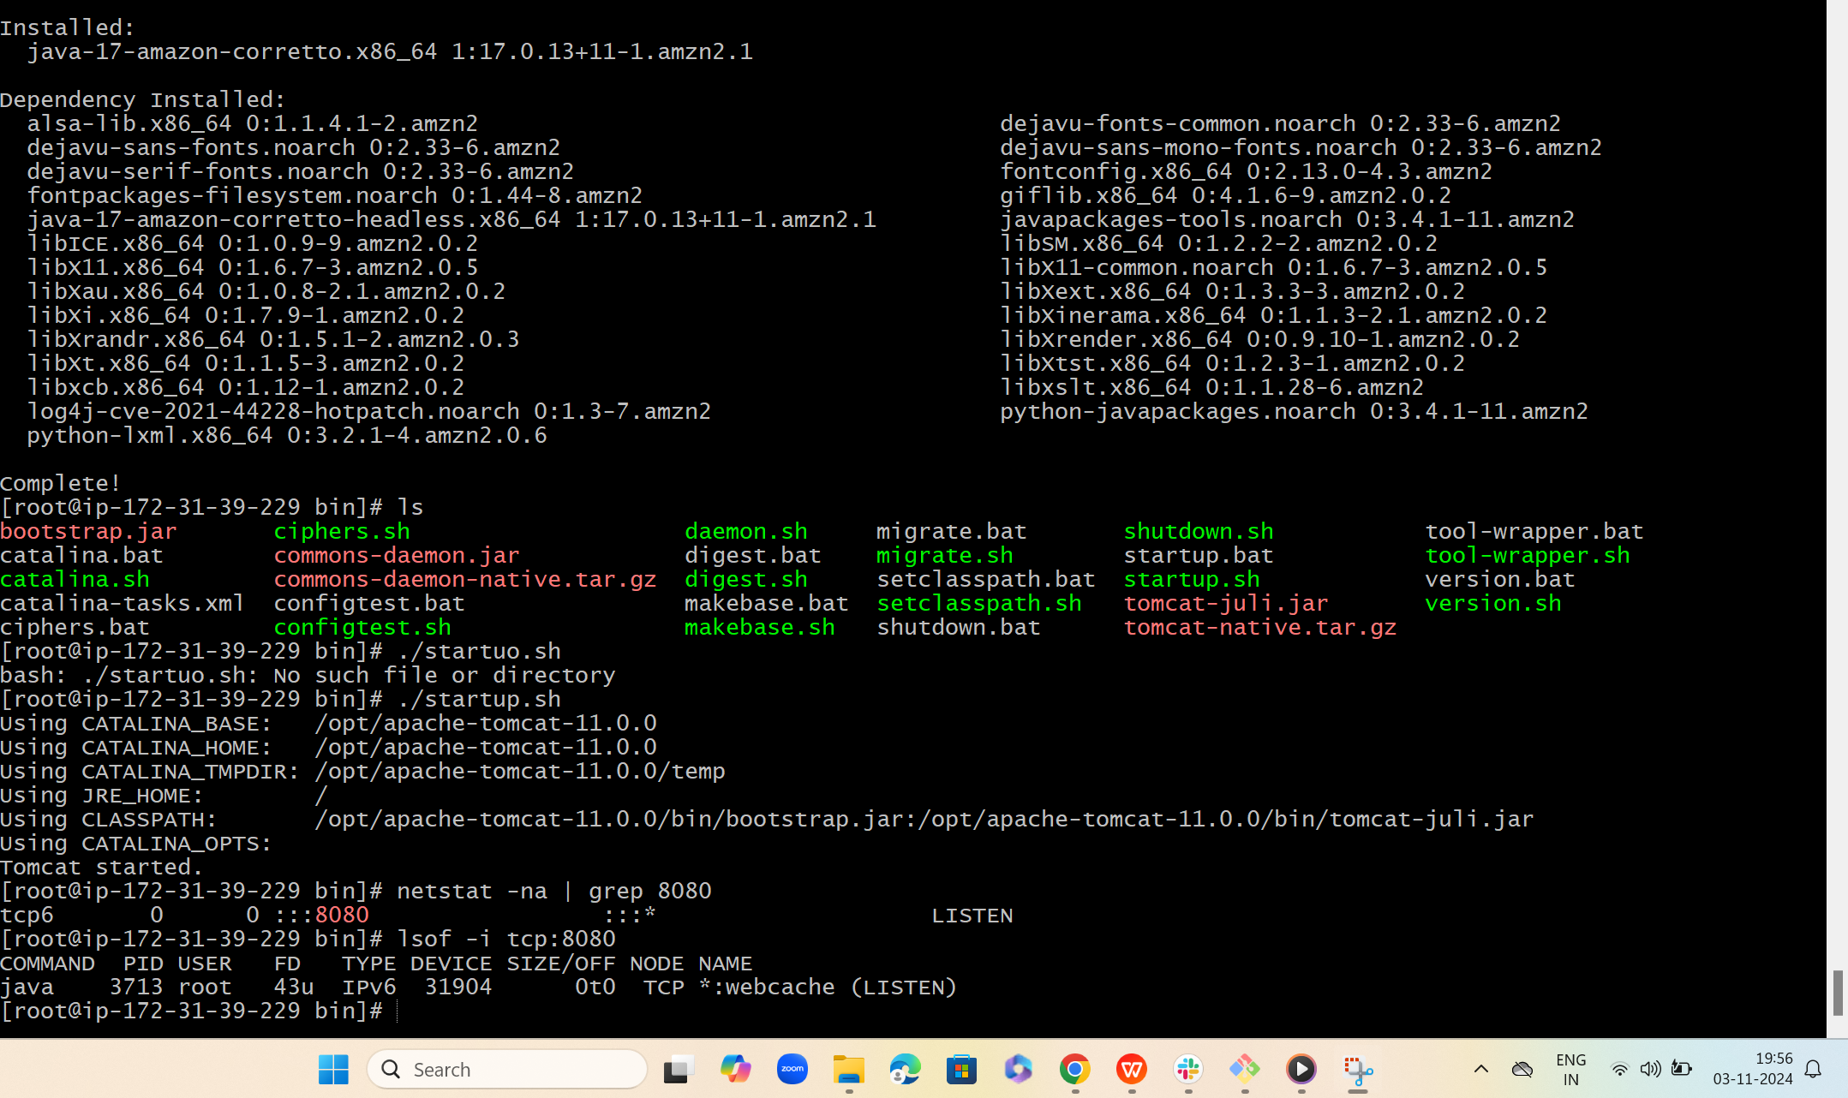

Port no 8082  
  
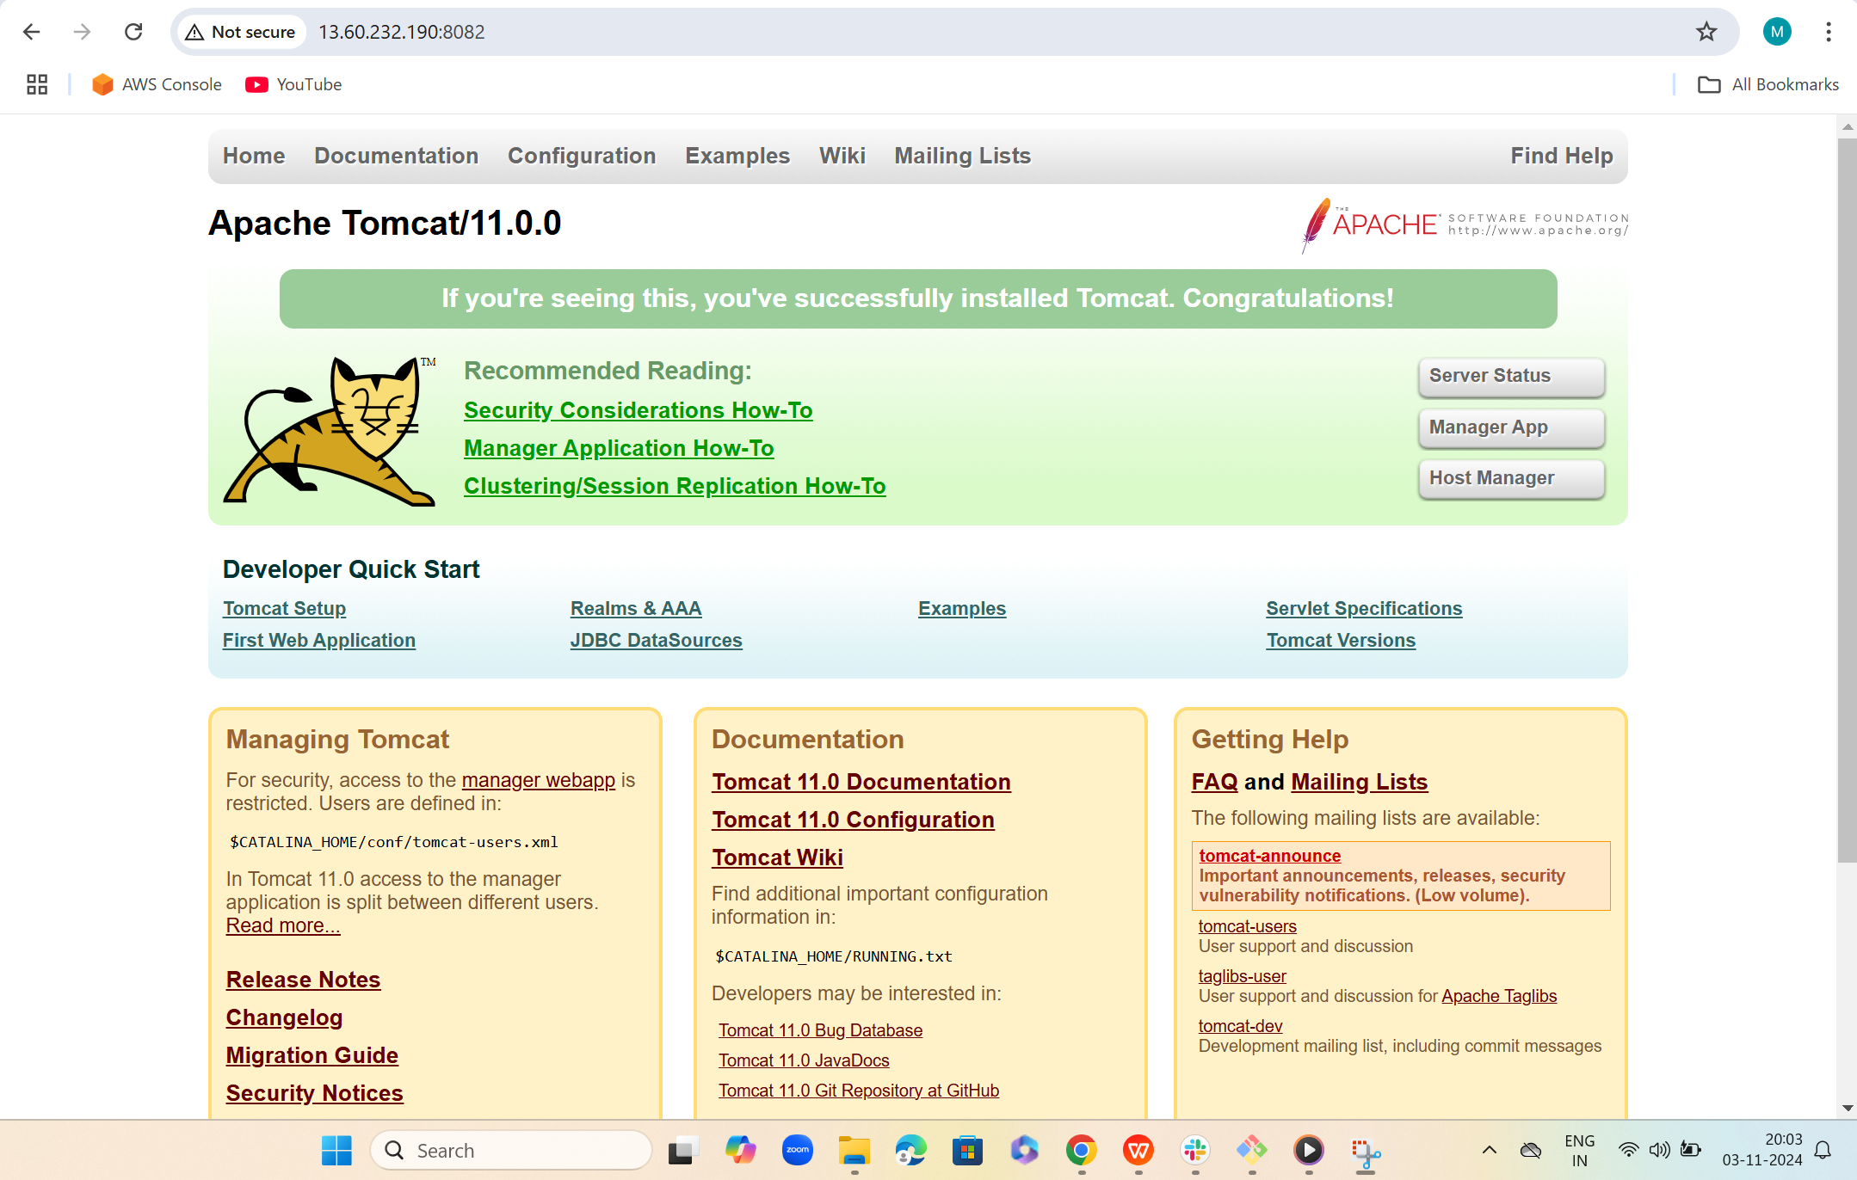

1. Deploy a sample app on webapps

